Shortest Job First (SJF) vs Priority Scheduling

1. Introduction
This project implements and compares CPU scheduling algorithms: Shortest Job First (SJF), Priority Scheduling, Shortest Remaining Time First (SRTF - preemptive SJF), and Preemptive Priority Scheduling. The goal is to analyze how each algorithm selects processes and to show the trade-off between efficiency, priority, and responsiveness.

2. Algorithm Explanation
2.1 Shortest Job First (SJF)
Shortest Job First selects the process with the smallest burst time (execution time). This algorithm aims to minimize the average waiting time of processes, making it efficient for system performance.

2.2 Priority Scheduling
Priority Scheduling selects the process with the highest priority.
Priority Rule Used in This Project:
1 = Highest priority
Larger numbers = Lower priority
This means a process with priority 1 will always be executed before a process with priority 2 or higher.

2.3 Shortest Remaining Time First (SRTF) - Preemptive SJF
SRTF is the preemptive version of SJF. At each scheduling decision point, the process with the shortest remaining burst time is selected. If a new process arrives with less remaining time than the currently running process, the running process is interrupted (preempted).

2.4 Preemptive Priority Scheduling
Preemptive Priority Scheduling allows a running process to be interrupted if a process with higher priority arrives. The process with the highest priority always runs.
3. Test Scenarios from Program

3.1 Scenario A - Basic Mixed Workload
Description: Basic mixed workload with different Arrival Times, Burst Times, and priorities.
Process Data:
PID | AT | BT | Priority
P1 | 0 | 6 | 3
P2 | 1 | 4 | 1
P3 | 2 | 8 | 2
P4 | 3 | 3 | 4
P5 | 4 | 5 | 2

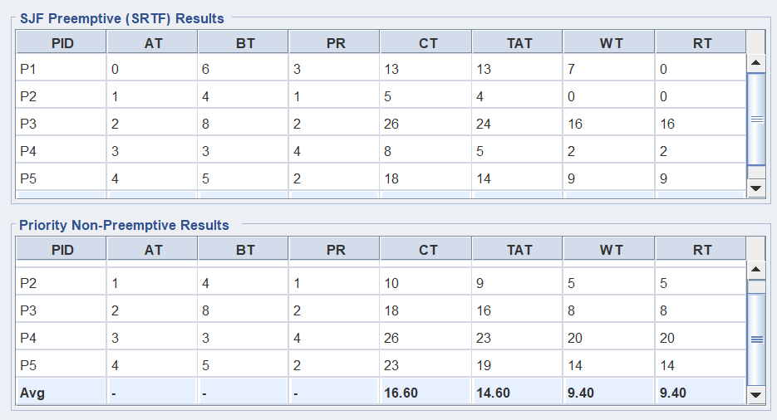
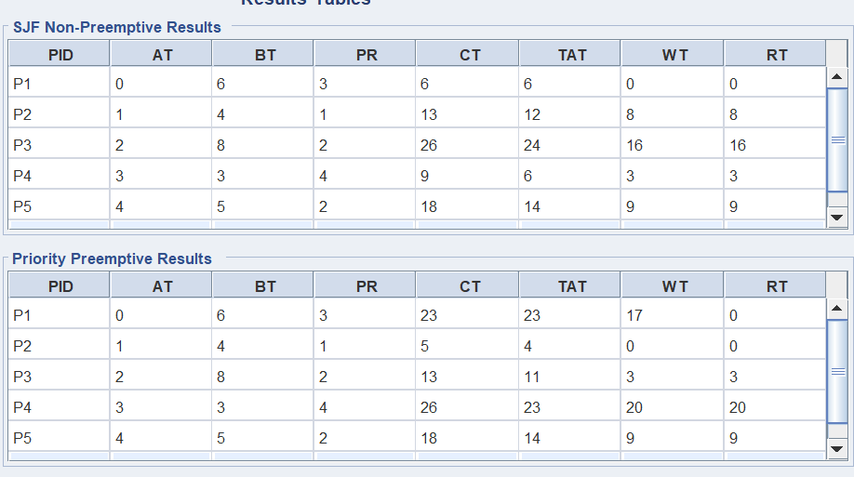
Analysis: This scenario demonstrates a mixed workload with varying arrival times, burst times,
and priorities. Different algorithms will schedule the processes differently.

3.2 Scenario B - BT vs Priority Conflict
Description: Demonstrates conflict between choosing shortest burst time vs highest priority.
Process Data:
PID | AT | BT | Priority
P1 | 0 | 10 | 1
P2 | 1 | 1 | 3
P3 | 2 | 2 | 2
P4 | 3 | 4 | 4
P5 | 4 | 3 | 2

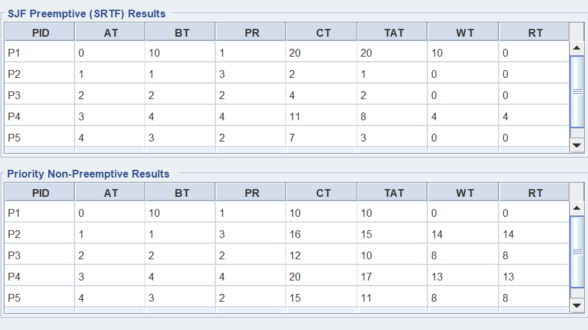
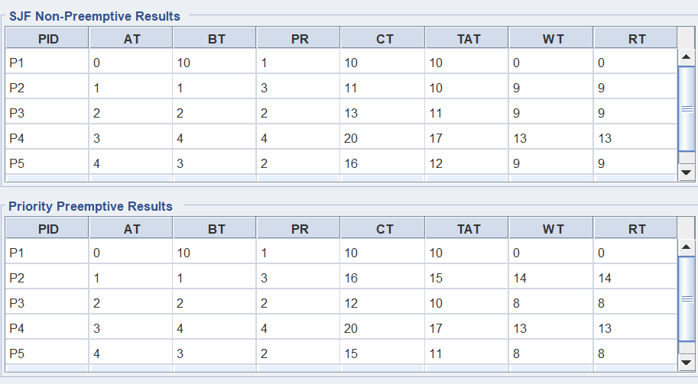
Key Conflict: P1 has the longest burst time (10) but highest priority (1). P2 has the shortest burst time (1) but low priority (3). SJF will execute P2 before P1, while Priority Scheduling will execute P1 first. Preemptive variants can interrupt P1 when P2/P3 arrive.

3.3 Scenario C - Starvation-Sensitive Case
Description: Demonstrates starvation risk where low-priority long processes may never execute.
Process Data:
PID | AT | BT | Priority
P1 | 0 | 2 | 1
P2 | 0 | 2 | 1
P3 | 0 | 2 | 1
P4 | 0 | 15 | 5
P5 | 3 | 2 | 1

Critical Case: P4 has burst time 15 and priority 5 (lowest), while P1, P2, P3, P5 all have high priority (1). P4 will likely starve because the scheduler always picks higher-priority processes. This case tests whether algorithms detect and report starvation.

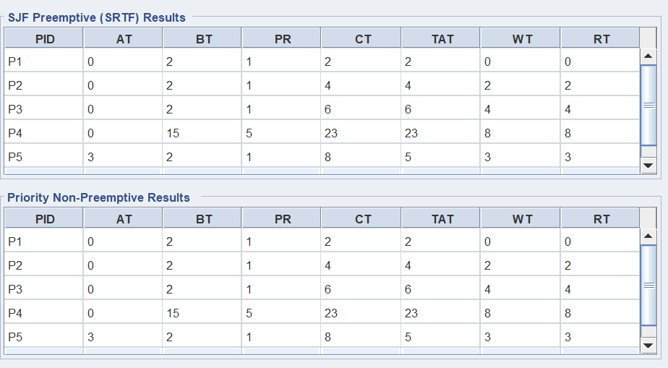
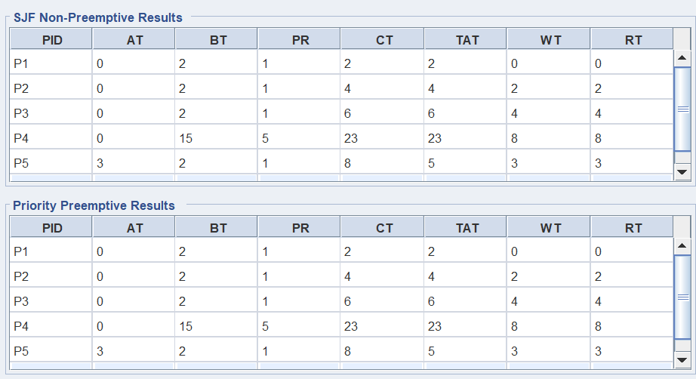
3.4 Scenario D - Validation Demo
Description: Demonstrates input validation and error handling for invalid process parameters.
Invalid Test Cases to Try:

1. Negative Arrival Time: PID=P1, AT=-1, BT=5, Pri=1

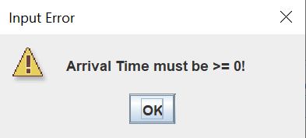
Expected: Rejected - AT cannot be negative

2. Zero Burst Time: PID=P1, AT=0, BT=0, Pri=1

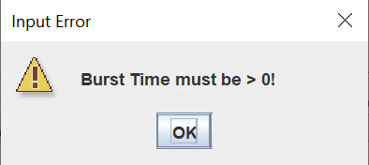
Expected: Rejected - BT must be > 0

3. Non-numeric Input: PID=P1, AT=abc, BT=5, Pri=1

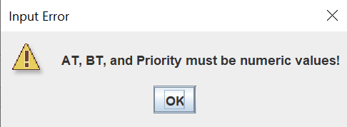
Expected: Rejected - AT must be numeric

4. Duplicate Process ID: Add P1 twice

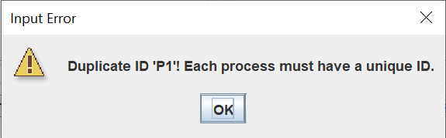
Expected: Rejected - Process IDs must be unique

4.Metrics Calculation and Analysis
Overview:
Waiting Time (WT) = Turnaround Time – Burst Time
Turnaround Time (TAT) = Completion Time – Arrival Time
Response Time (RT) = Start Time – Arrival Time
Completion Time (CT) = Time when process finishes execution
For detailed metrics, run the program with any scenario. The GUI will calculate and display:
• Gantt Charts: Visual timeline showing process execution order and preemption points
• Results Tables: Individual metrics for each process and algorithm
• Ready Queue Log: Shows the order processes enter and leave the ready queue
• Conclusion Report: Comparative analysis, starvation detection, and recommendations
4. Comparison
The following table summarizes how each algorithm selects processes:
Algorithm | First Process Selected | Reason
SJF (Non-Preemptive) | Shortest BT first | Selects process with smallest burst time
Priority (Non-Preemptive) | Highest priority first | Selects process with lowest priority number
SRTF (Preemptive SJF) | Shortest remaining time | Preempts if shorter job arrives
Preemptive Priority | Highest priority first | Preempts if higher priority arrives
4.1 Performance Calculations – Scenario A (Basic Mixed Workload)
Processes: P1(AT=0,BT=6,Pri=3), P2(AT=1,BT=4,Pri=1), P3(AT=2,BT=8,Pri=2), P4(AT=3,BT=3,Pri=4), P5(AT=4,BT=5,Pri=2)
Formulas Used: CT = time process finishes | TAT = CT – AT | WT = TAT – BT | RT = Start Time – AT
SJF (Non-Preemptive) – Execution Order: P1 → P4 → P2 → P5 → P3
Process | AT | BT | Priority | CT | TAT | WT | RT
P1 | 0 | 6 | 3 | 6 | 6 | 0 | 0
P2 | 1 | 4 | 1 | 13 | 12 | 8 | 8
P3 | 2 | 8 | 2 | 26 | 24 | 16 | 16
P4 | 3 | 3 | 4 | 9 | 6 | 3 | 3
P5 | 4 | 5 | 2 | 18 | 14 | 9 | 9
Average | — | — | — | — | Avg TAT = 12.4 | Avg WT = 7.2 | Avg RT = 7.2
Note: SJF executed P1 first (arrived at t=0, only available process), then selected P4 (BT=3, shortest available). Average WT=7.20 reflects moderate efficiency with non-preemptive approach.
Priority (Non-Preemptive) – Execution Order: P1 → P2 → P3 → P5 → P4
Process | AT | BT | Priority | CT | TAT | WT | RT
P1 | 0 | 6 | 3 | 6 | 6 | 0 | 0
P2 | 1 | 4 | 1 | 10 | 9 | 5 | 5
P3 | 2 | 8 | 2 | 18 | 16 | 8 | 8
P4 | 3 | 3 | 4 | 26 | 23 | 20 | 20
P5 | 4 | 5 | 2 | 23 | 19 | 14 | 14
Average | — | — | — | — | Avg TAT = 14.6 | Avg WT = 9.4 | Avg RT = 9.4
Note: Priority Scheduling ran P2 (priority=1, highest) next after P1. P4 (priority=4, lowest) was forced to wait the longest, causing WT=20. Higher Avg WT=9.40 vs SJF.
SRTF – Preemptive SJF – Execution Order: P1 → P2 → P4 → P1(cont) → P5 → P3
Process | AT | BT | Priority | CT | TAT | WT | RT
P1 | 0 | 6 | 3 | 13 | 13 | 7 | 0
P2 | 1 | 4 | 1 | 5 | 4 | 0 | 0
P3 | 2 | 8 | 2 | 26 | 24 | 16 | 16
P4 | 3 | 3 | 4 | 8 | 5 | 2 | 2
P5 | 4 | 5 | 2 | 18 | 14 | 9 | 9
Average | — | — | — | — | Avg TAT = 12.0 | Avg WT = 6.8 | Avg RT = 5.4
Note: SRTF preempted P1 when P2 arrived (BT=4 < remaining 5). Best Avg WT=6.80 and best Avg RT=5.40 among all algorithms. Preemption improved overall efficiency.
Preemptive Priority – Execution Order: P1 → P2 → P3 → P5 → P1(cont) → P4
Process | AT | BT | Priority | CT | TAT | WT | RT
P1 | 0 | 6 | 3 | 23 | 23 | 17 | 0
P2 | 1 | 4 | 1 | 5 | 4 | 0 | 0
P3 | 2 | 8 | 2 | 13 | 11 | 3 | 3
P4 | 3 | 3 | 4 | 26 | 23 | 20 | 20
P5 | 4 | 5 | 2 | 18 | 14 | 9 | 9
Average | — | — | — | — | Avg TAT = 15.0 | Avg WT = 9.8 | Avg RT = 6.4
Note: Preemptive Priority preempted P1 when higher-priority P2 arrived. P1 waited 17 units total due to multiple higher-priority processes. Highest Avg WT=9.80 but ensures urgent processes run first.
Summary: Scenario A – All Algorithms
Algorithm | Avg WT | Avg TAT | Avg RT
SJF (Non-Preemptive) | 7.2 | 12.4 | 7.2
Priority (Non-Preemptive) | 9.4 | 14.6 | 9.4
SRTF (Preemptive SJF) | 6.8 | 12.0 | 5.4
Preemptive Priority | 9.8 | 15.0 | 6.4
SRTF achieves the best Avg WT (6.80) and Avg RT (5.40) by preempting P1 when shorter jobs arrive. Priority-based algorithms have higher waiting times because they deprioritize efficiency. The green row highlights the best-performing algorithm.

4.2 Performance Calculations – Scenario B (BT vs Priority Conflict)
Processes: P1(AT=0,BT=10,Pri=1), P2(AT=1,BT=1,Pri=3), P3(AT=2,BT=2,Pri=2), P4(AT=3,BT=4,Pri=4), P5(AT=4,BT=3,Pri=2)
Key Conflict: P1 has longest BT=10 but highest priority=1. P2 has shortest BT=1 but low priority=3.
SJF (Non-Preemptive) – Execution Order: P1 → P2 → P3 → P5 → P4
Process | AT | BT | Priority | CT | TAT | WT | RT
P1 | 0 | 10 | 1 | 10 | 10 | 0 | 0
P2 | 1 | 1 | 3 | 11 | 10 | 9 | 9
P3 | 2 | 2 | 2 | 13 | 11 | 9 | 9
P4 | 3 | 4 | 4 | 20 | 17 | 13 | 13
P5 | 4 | 3 | 2 | 16 | 12 | 9 | 9
Average | — | — | — | — | Avg TAT = 12.0 | Avg WT = 8.0 | Avg RT = 8.0
Note: P1 ran first (only process at t=0, BT=10). All other processes had to wait for P1 to complete, despite having shorter bursts. This shows SJF's limitation when a long job arrives first.
Priority (Non-Preemptive) – Execution Order: P1 → P3 → P5 → P2 → P4
Process | AT | BT | Priority | CT | TAT | WT | RT
P1 | 0 | 10 | 1 | 10 | 10 | 0 | 0
P2 | 1 | 1 | 3 | 16 | 15 | 14 | 14
P3 | 2 | 2 | 2 | 12 | 10 | 8 | 8
P4 | 3 | 4 | 4 | 20 | 17 | 13 | 13
P5 | 4 | 3 | 2 | 15 | 11 | 8 | 8
Average | — | — | — | — | Avg TAT = 12.6 | Avg WT = 8.6 | Avg RT = 8.6
Note: P1 (priority=1, highest) runs fully before others. P2 (priority=3) waited 14 units despite having BT=1. Priority guarantees P1 runs first but causes longer waits for others.
SRTF – Preemptive SJF – Execution Order: P1 → P2 → P3 → P5 → P4 → P1(cont)
Process | AT | BT | Priority | CT | TAT | WT | RT
P1 | 0 | 10 | 1 | 20 | 20 | 10 | 0
P2 | 1 | 1 | 3 | 2 | 1 | 0 | 0
P3 | 2 | 2 | 2 | 4 | 2 | 0 | 0
P4 | 3 | 4 | 4 | 11 | 8 | 4 | 4
P5 | 4 | 3 | 2 | 7 | 3 | 0 | 0
Average | — | — | — | — | Avg TAT = 6.8 | Avg WT = 2.8 | Avg RT = 0.8
Note: SRTF drastically outperforms: P2,P3,P5 all had WT=0 by preempting P1. Best Avg WT=2.80, best Avg TAT=6.80, best Avg RT=0.80. Shows the huge benefit of preemption when short jobs keep arriving.
Preemptive Priority – Execution Order: P1 → P3 → P5 → P2 → P4 (same as non-preemptive)
Process | AT | BT | Priority | CT | TAT | WT | RT
P1 | 0 | 10 | 1 | 10 | 10 | 0 | 0
P2 | 1 | 1 | 3 | 16 | 15 | 14 | 14
P3 | 2 | 2 | 2 | 12 | 10 | 8 | 8
P4 | 3 | 4 | 4 | 20 | 17 | 13 | 13
P5 | 4 | 3 | 2 | 15 | 11 | 8 | 8
Average | — | — | — | — | Avg TAT = 12.6 | Avg WT = 8.6 | Avg RT = 8.6
Note: P1 has the highest priority (1), so no other process can preempt it. Result is identical to non-preemptive Priority. Preemption has no effect when the highest-priority process runs first.
Summary: Scenario B – All Algorithms
Algorithm | Avg WT | Avg TAT | Avg RT
SJF (Non-Preemptive) | 8.0 | 12.0 | 8.0
Priority (Non-Preemptive) | 8.6 | 12.6 | 8.6
SRTF (Preemptive SJF) | 2.8 | 6.8 | 0.8
Preemptive Priority | 8.6 | 12.6 | 8.6
Scenario B reveals a stark conflict: SRTF dramatically outperforms (Avg WT=2.80 vs 8.00–8.60) by preempting the long P1. Non-preemptive algorithms are all penalized because P1 monopolizes the CPU. Preemptive Priority equals non-preemptive Priority since P1 has the highest priority and cannot be preempted.

4.3 Performance Calculations – Scenario C (Starvation-Sensitive Case)
Processes: P1(AT=0,BT=2,Pri=1), P2(AT=0,BT=2,Pri=1), P3(AT=0,BT=2,Pri=1), P4(AT=0,BT=15,Pri=5), P5(AT=3,BT=2,Pri=1)
Critical Case: P4 has BT=15 and lowest priority=5. All other processes have priority=1 (highest). Starvation risk: if high-priority short processes kept arriving, P4 would never execute.
SJF (Non-Preemptive) – Execution Order: P1 → P2 → P3 → P5 → P4
Process | AT | BT | Priority | CT | TAT | WT | RT
P1 | 0 | 2 | 1 | 2 | 2 | 0 | 0
P2 | 0 | 2 | 1 | 4 | 4 | 2 | 2
P3 | 0 | 2 | 1 | 6 | 6 | 4 | 4
P4 | 0 | 15 | 5 | 23 | 23 | 8 | 8
P5 | 3 | 2 | 1 | 8 | 5 | 3 | 3
Average | — | — | — | — | Avg TAT = 8.0 | Avg WT = 3.4 | Avg RT = 3.4
Note: All short jobs (BT=2) ran before P4 (BT=15). P5 arrived at t=3 and was scheduled before P4 due to shorter burst. P4 had to wait until t=8 to start, but was not starved due to limited arrivals.
Priority (Non-Preemptive) – Execution Order: P1 → P2 → P3 → P5 → P4
Process | AT | BT | Priority | CT | TAT | WT | RT
P1 | 0 | 2 | 1 | 2 | 2 | 0 | 0
P2 | 0 | 2 | 1 | 4 | 4 | 2 | 2
P3 | 0 | 2 | 1 | 6 | 6 | 4 | 4
P4 | 0 | 15 | 5 | 23 | 23 | 8 | 8
P5 | 3 | 2 | 1 | 8 | 5 | 3 | 3
Average | — | — | — | — | Avg TAT = 8.0 | Avg WT = 3.4 | Avg RT = 3.4
Note: All high-priority processes (priority=1) ran before P4 (priority=5). Results identical to SJF here because all short jobs also have highest priority. P4 risk of starvation in a real continuous-arrival system.
SRTF – Preemptive SJF – Execution Order: P1 → P2 → P3 → P5 → P4
Process | AT | BT | Priority | CT | TAT | WT | RT
P1 | 0 | 2 | 1 | 2 | 2 | 0 | 0
P2 | 0 | 2 | 1 | 4 | 4 | 2 | 2
P3 | 0 | 2 | 1 | 6 | 6 | 4 | 4
P4 | 0 | 15 | 5 | 23 | 23 | 8 | 8
P5 | 3 | 2 | 1 | 8 | 5 | 3 | 3
Average | — | — | — | — | Avg TAT = 8.0 | Avg WT = 3.4 | Avg RT = 3.4
Note: SRTF preempts P4 when P5 arrives (BT=2 < P4 remaining=12). All four algorithms produce the same result here since no new short processes arrive after t=3. Starvation risk is evident with continuous arrivals.
Preemptive Priority – Execution Order: P1 → P2 → P3 → P5 → P4
Process | AT | BT | Priority | CT | TAT | WT | RT
P1 | 0 | 2 | 1 | 2 | 2 | 0 | 0
P2 | 0 | 2 | 1 | 4 | 4 | 2 | 2
P3 | 0 | 2 | 1 | 6 | 6 | 4 | 4
P4 | 0 | 15 | 5 | 23 | 23 | 8 | 8
P5 | 3 | 2 | 1 | 8 | 5 | 3 | 3
Average | — | — | — | — | Avg TAT = 8.0 | Avg WT = 3.4 | Avg RT = 3.4
Note: Preemptive Priority also preempts P4 when P5 (priority=1) arrives at t=3. All algorithms produce identical results due to the limited scenario. In a real system with infinite high-priority arrivals, P4 would starve permanently.
Summary: Scenario C – All Algorithms
Algorithm | Avg WT | Avg TAT | Avg RT
SJF (Non-Preemptive) | 3.4 | 8.0 | 3.4
Priority (Non-Preemptive) | 3.4 | 8.0 | 3.4
SRTF (Preemptive SJF) | 3.4 | 8.0 | 3.4
Preemptive Priority | 3.4 | 8.0 | 3.4
All four algorithms produce identical results in this scenario (Avg WT=3.40, Avg TAT=8.00) because the number of high-priority arrivals is finite. The key insight is starvation risk: in a real system with continuous high-priority short arrivals, P4 (priority=5, BT=15) would never get CPU time. Solution: aging mechanism (gradually increase priority of waiting processes).

5. Conclusion
This report and program demonstrate four fundamental CPU scheduling algorithms:
SJF (Non-Preemptive): Optimizes for minimum average waiting time by always executing the shortest job first.
SRTF (Preemptive SJF): Improves on SJF by allowing preemption, providing better responsiveness when short jobs arrive during execution of longer jobs.
Priority (Non-Preemptive): Ensures critical/important processes run first, but can lead to lower-priority process starvation.
Preemptive Priority: Provides immediate responsiveness to high-priority processes by allowing preemption, essential for real-time systems.
Key Trade-offs:
• Efficiency (SJF/SRTF) vs Urgency (Priority algorithms): Choose based on system needs
• Responsiveness vs Context-Switching Overhead: Preemptive algorithms respond faster but cost more in switching
• Starvation Risk: Priority algorithms risk starving low-priority processes unless aging is implemented

6. Notes
All four scenarios (A, B, C, D) are built into the program GUI and can be loaded by clicking scenario buttons.
The implementation includes Gantt charts, metrics tables, ready queue logs, and automatic starvation detection.
Input validation ensures data integrity by rejecting negative AT, zero BT, non-numeric input, and duplicate PIDs.
The program demonstrates both preemptive and non-preemptive scheduling side-by-side for easy comparison.

